Kafka

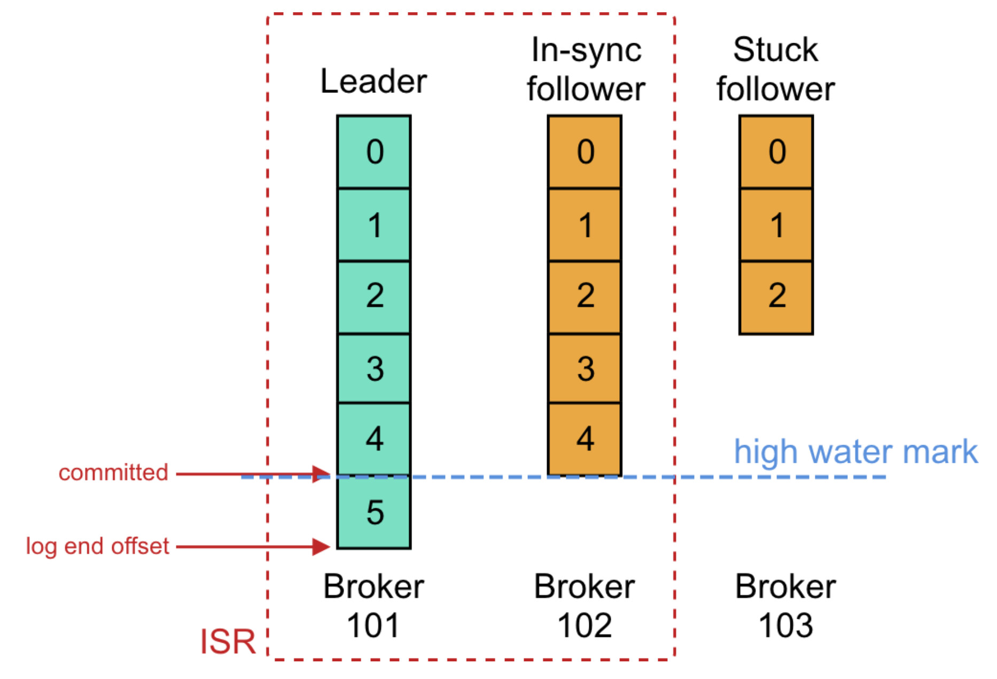

Datawarehouse Data lake Delta lake

DW->ACID / Slowly changing Dimension maintains history

Data lake → No ACID property

Delta lake → ACID properties → delta table

Insert, update, delete

Delta lake → time travel

Overview of Data Management:

Explanation: Data management involves the process of collecting, storing, processing, and managing data throughout its lifecycle. It includes various activities such as data integration, data quality management, and data governance.

Tools: Tools like Apache Hadoop, Apache Spark, and Talend are commonly used for data management.

Example: Imagine a retail company managing customer data, product information, and sales data in a centralized system for efficient decision-making.

b. Importance of Data Management at Enterprises:

Explanation: Effective data management is crucial for enterprises to make informed decisions, ensure data accuracy, comply with regulations, and gain a competitive edge.

Tools: Enterprise Data Management (EDM) tools like Informatica, IBM InfoSphere, and Microsoft SQL Server are widely used.

Example: A financial institution needs accurate customer data for risk management and compliance with regulatory requirements.

c. Multidimensional Data Representation and Manipulation:

Explanation: This involves organizing data into a multidimensional structure, often used in data warehouses for complex analysis. It allows users to explore data along multiple dimensions.

Tools: OLAP (Online Analytical Processing) tools like Microsoft Excel (with PivotTables), Tableau, and Power BI.

Example: Analyzing sales data by product category, region, and time to identify trends and make strategic decisions.

d. Design Practices and Methodologies:

Explanation: Design practices in data management include data modeling, ETL (Extract, Transform, Load) processes, and following methodologies like Agile or Waterfall.

Tools: ERwin, Oracle SQL Developer Data Modeler, and Microsoft Visio for data modeling. Talend, Apache NiFi, and Informatica for ETL.

Example: Designing a data model for an e-commerce platform to support inventory management and order processing.

e. Understand Data Warehouse, Data Lake, Lake House:

Explanation: Data warehouse stores structured data for reporting and analysis. Data lakes store raw and unstructured data. A lake house combines features of both for flexibility.

Tools: Snowflake, Amazon Redshift, and Google BigQuery for data warehouses. Hadoop, Amazon S3, and Azure Data Lake Storage for data lakes.

Example: A company stores sales transaction data in a data warehouse for monthly financial reports and raw customer feedback in a data lake for future sentiment analysis.

f. Data Management Architecture:

Explanation: This involves designing the structure and components of a data management system, including databases, processing engines, and integration layers.

Tools: Architecture design tools like Lucidchart, draw.io, and enterprise-level solutions like MuleSoft.

Example: Designing a cloud-based data architecture for a healthcare organization to securely store patient records and enable real-time analytics.

g. Quality Check - How to Build a Quality Check Pipeline:

Explanation: Quality checks ensure data accuracy and reliability. Building a quality check pipeline involves creating automated processes to validate and cleanse data.

Tools: Apache NiFi, Talend Data Quality, and Informatica Data Quality.

Example: Implementing data quality checks in a healthcare system to identify and correct errors in patient records.

h. Governance - How to Create Governance Layer in Pipeline:

Explanation: Data governance ensures data is used appropriately, complies with regulations, and follows organizational policies. Creating a governance layer involves implementing controls and monitoring mechanisms.

Tools: Collibra, Informatica Axon, and Apache Atlas for metadata management.

Example: Establishing data governance policies to control access to sensitive financial data in a banking system.

i. Migration - What are the Checklists for Migration:

Explanation: Data migration involves moving data from one system to another. Checklists include planning, data profiling, testing, and validation steps.

Tools: AWS Database Migration Service, Microsoft Data Migration Assistant, and Oracle Data Pump.

Example: Migrating customer data from an on-premise CRM system to a cloud-based CRM platform.

j. Data Security - How to Track Security and Lineage:

Explanation: Ensuring data security involves implementing access controls, encryption, and monitoring. Tracking lineage helps trace the origin and movement of data.

Tools: Apache Ranger, HashiCorp Vault, and Varonis for data security. Apache Atlas for data lineage.

Example: Securing personal information in a financial database and tracking how it's accessed and used.

===========================================

**Handling log file in pyspark**

IP Address: 64.242.88.10 - The IP address of the client or user who made the request.

Timestamp: [07/Mar/2004:16:05:49 -0800] - The date and time of the request, along with the timezone offset (-0800).

Request Line: "GET /twiki/bin/edit/Main/Double_bounce_sender?topicparent=Main.ConfigurationVariables HTTP/1.1" - The type of HTTP request (GET), the requested resource (/twiki/bin/edit/Main/Double_bounce_sender?topicparent=Main.ConfigurationVariables), and the HTTP protocol version (HTTP/1.1).

Status Code: 401 - The HTTP status code returned by the server. In this case, 401 indicates unauthorized access.

Bytes Sent: 12846 - The number of bytes sent from the server to the client.

Now, let's analyze a few entries:

The first entry is attempting to edit a topic in the "Main" namespace of a TWiki site but is unauthorized (Status Code 401).

The second entry is successfully retrieving the difference between two revisions of a TWiki page.

The seventh entry is attempting to view the changes in the "Main" namespace but is authorized (Status Code 200).

These logs are crucial for web administrators to monitor and analyze server activity, troubleshoot issues, and ensure the security of the web application. The IP address, timestamp, request type, and status code are particularly important for this analysis.

To read this log file into a PySpark DataFrame, you can use the spark.read.text method, and then parse the columns using PySpark functions. Here's a basic example assuming your log entries follow the given format:

python

Copy code

from pyspark.sql import SparkSession

from pyspark.sql.functions import split, regexp_extract

# Create a Spark session

spark = SparkSession.builder.appName("LogAnalysis").getOrCreate()

# Define the log file path

log_file_path = "path/to/your/logfile.log"

# Read the log file into a DataFrame

log_data = spark.read.text(log_file_path)

# Define a regular expression pattern to extract information from log entries

log_pattern = r'(\S+) - - \[([^\]]+)\] "(\S+ \S+ \S+)" (\d+) (\d+)'

# Use regexp_extract to create new columns based on the defined pattern

log_data = log_data.select(

regexp_extract('value', log_pattern, 1).alias('ip'),

regexp_extract('value', log_pattern, 2).alias('timestamp'),

regexp_extract('value', log_pattern, 3).alias('request'),

regexp_extract('value', log_pattern, 4).cast('int').alias('status_code'),

regexp_extract('value', log_pattern, 5).cast('int').alias('bytes_sent')

)

# Show the DataFrame

log_data.show(truncate=False)

# Stop the Spark session

spark.stop()

In this example:

We use regexp_extract to extract specific fields from each log entry using the defined regular expression pattern.

The regular expression pattern captures the IP address, timestamp, request line, status code, and bytes sent.

The resulting DataFrame (log_data) will have columns for IP, timestamp, request, status_code, and bytes_sent.

Please replace "path/to/your/logfile.log" with the actual path to your log file. Adjust the regular expression pattern if your log entries have a different format.

============sample code to read email =========

In PySpark, you can use regular expressions to extract email addresses from a DataFrame. Here's an example of how you can create a PySpark DataFrame containing email addresses by using the regexp_extract function:

from pyspark.sql import SparkSession

from pyspark.sql.functions import regexp_extract

# Create a Spark session

spark = SparkSession.builder.appName("EmailExtraction").getOrCreate()

# Sample data with email addresses

data = [("John", "john@example.com"),

("Alice", "alice123@gmail.com"),

("Bob", "bob.smith@yahoo.com")]

# Define the schema

schema = ["name", "text"]

# Create a DataFrame

df = spark.createDataFrame(data, schema=schema)

# Regular expression pattern for extracting email addresses

email_pattern = r'\b[A-Za-z0-9._%+-]+@[A-Za-z0-9.-]+\.[A-Z|a-z]{2,}\b'

# Use regexp_extract to extract email addresses

df_result = df.withColumn("email", regexp_extract("text", email_pattern, 0))

# Show the resulting DataFrame

df_result.show(truncate=False)

# Stop the Spark session

spark.stop()

In this example:

The regexp_extract function is used to extract email addresses from the "text" column of the DataFrame.

The email_pattern is a simple regular expression for extracting email addresses. Note that this is a basic pattern and may not cover all edge cases.

Adjust the email_pattern if needed, depending on the specific email address patterns you encounter in your data. Email address validation using regular expressions can be quite complex due to the variety of valid formats, so be mindful of potential variations in your data.

User

log_pattern = r'(\S+) - - \[([^\]]+)\] "(\S+ \S+ \S+)" (\d+) (\d+)'

ChatGPT

It seems like you're using a log pattern for parsing log entries. The provided regular expression pattern r'(\S+) - - \[([^\]]+)\] "(\S+ \S+ \S+)" (\d+) (\d+)' appears to be designed to extract various components from a common log format.

Let's break down the pattern:

(\S+): Matches and captures one or more non-whitespace characters, representing the IP address.

- -: Matches the literal string " - - ".

\[( [^\]]+) \]: Matches and captures the timestamp enclosed in square brackets.

"(\S+ \S+ \S+)": Matches and captures the request line enclosed in double quotes. This often includes the HTTP method, requested resource, and HTTP protocol version.

(\d+): Matches and captures one or more digits, representing the HTTP status code.

(\d+): Matches and captures one or more digits, representing the number of bytes sent.

Given your log entry examples, this pattern seems to be a good fit for the log format you provided.

If you encounter variations or additional fields in your log entries, you may need to modify the pattern accordingly. Additionally, always consider the actual structure of your log entries to ensure accurate parsing.

Certainly, let's break down the components of the regular expression r'(\S+) - - \[([^\]]+)\] "(\S+ \S+ \S+)" (\d+) (\d+)':

(\S+):

(\S+) captures one or more non-whitespace characters. This is used to capture the IP address in the log entry.

- -:

- - is a literal string that matches the space-hyphen-space sequence.

\[( [^\]]+) \]:

\[( [^\]]+) \] matches a timestamp enclosed in square brackets.

\[: Matches the opening square bracket.

([^\]]+): Captures one or more characters that are not a closing square bracket.

\]: Matches the closing square bracket.

"(\S+ \S+ \S+)":

\": Matches the opening double quote.

(\S+ \S+ \S+): Captures three groups of non-whitespace characters separated by spaces. This typically represents the request line in the log entry.

\": Matches the closing double quote.

(\d+):

(\d+) captures one or more digits. This is used to capture the HTTP status code.

(\d+):

(\d+) captures one or more digits. This is used to capture the number of bytes sent.

Overall, the regular expression is designed to match and capture specific components of a log entry, including the IP address, timestamp, request line, HTTP status code, and the number of bytes sent. The use of parentheses ( ... ) creates capture groups, allowing you to extract specific information from the log entry when using this regular expression in tools or programming languages that support regular expression matching and capture groups